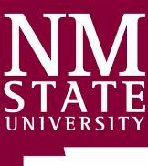

SAVE THE DATE!
2019 NEW MEXICO HAY ASSOCIATION
SOUTHWEST HAY & FORAGE CONFERENCE & TRADE SHOW
JANUARY 23-25, 2019
RUIDOSO CONVENTION CENTER, RUIDOSO NEW MEXICO
Irrigation Management; Remote Sensing; Rodent/Wildlife Control; Weed Control; Weevil & Aphid Control; Annual Crops; Legislative Update & More!
EARLY REGISTRATION FORMS AVAILABLE FOR MORE INFO VISIT OUR WEBPAGE
ONLINE AT WWW.NMHAY.COM OR CALL 575-626-1688

4 New Mexico Pesticide Applicator CEUs Have Been Approved

